**Database HW6 MongoDB and NoSQL**

**Gabe Wallon**

**Section 1a:**

**1. What is Big Data?**  
A. A large spreadsheet.  
B. Data that cannot be stored on a single machine.  
C. Small-scale data used for personal projects.  
D. Data that can be easily managed in Excel.

**2. What is the primary advantage of using MongoDB over traditional relational databases for handling Big Data?**  
A. MongoDB is free and open source.  
B. MongoDB can handle unstructured data.  
C. MongoDB supports SQL querying.  
D. MongoDB is faster for small-scale data.

**Section 1b:**

1. **What is the importance of Big Data?**

Technology in the world today is generating huge amounts of data, data that comes in different forms, which is being collected to inform decision making, gain a competitive advantage, and improve customer experience.

1. **What do the 3 V’s of big data represent?**

The three V’s stand for Volume, Variety, and Velocity. Volume represents the rapidly growing amount of data being generated and collected in the world today. Variety represents the many different forms this data comes in such as video, photos, social media posts, etc. Velocity represents the speed at which data is being generated, and demanded, increasingly in real-time.

1. **What is NoSQL?**

NoSQL stands for “not only structured query language” and is a category of database management systems which do not store data in the traditional relational table architecture. These databases are built to allow for easy scaling, and the ability to house data and work with data coming in many different forms.

**Section 2:**

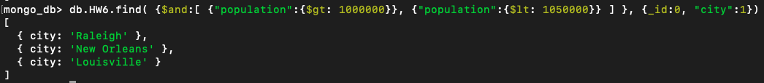db.HW6.find( {$and:[ {"population":{$gt: 1000000}}, {"population":{$lt: 1050000}} ] }, {_id:0, "city":1})

2.

db.HW6.aggregate([

{$sort: {"density":-1}},

{$project: {_id:0, "density":1, "city":1}},

{$limit: 1}

])

3.

db.HW6.aggregate([

{$match:{

$and:[{"state_id":"CA"}, {"population":{$gt: 2000000}}]

}

},

{$project: {_id:0, "city":1}}

])

4.

db.HW6.find({"density":{$gt: 3000}}).count()



5.

db.HW6.aggregate([

{$match: {"state_id":"NY"}},

{$group:{_id: "$state_id", avg_population:{$avg:"$population"}}}

])